Songs for CASA Assembly # 4


Dec. 23, 2008

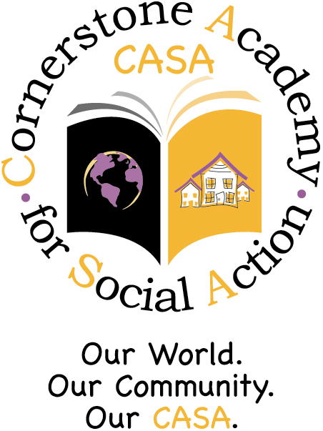

1 The Star-Spangled voc 1:26
2 Star-Spangled Banner 1:26
3 Lift Ev'ry Voice and Sing 2:04
4 The Riddle Song ??? 0:48
5 Five Winter Holidays 0:39
6 Come, Kwanzaa 1:11
7 Come, Kwanzaa voc 1:13
8 Chatter with the Angels 1:00
9 The Holiday Spiritvoc 3:09
10 HolidaySpirit_MIDI voc 3:58
11 The Holiday Spiri MIDI 3:56
12 Turn, Dreidl, Turn voc 0:57
13 Turn, Dreidl, Turn MIDI 0:49
14 Bells Are Ringing voc 1:25
15 Bells Are Ringing MIDI 1:22
16 Chicken Dance 2:25
17 Must Be Santa 3:00
18 Take_a_Test 2:13
19 Peacemakers 2:09
20 Hasta la Vista 0:39
CASA Music Corner:
www.corner189.com

