This Land is Your Land
by Woody Guthrie

This land is your land
This land is my land
From California
to the New York Island
From the redwood forest
to the Gulf Stream waters
This land was made
for you and me

[Chorus]

As I was walking
that ribbon of highway
I saw above me
that endless skyway
I saw below me
that golden valley
This land was made
for you and me

[Chorus]
As I was walking
I saw a sign there
And on the sign it said:
“NO TRESPASSING!”
But on the other side
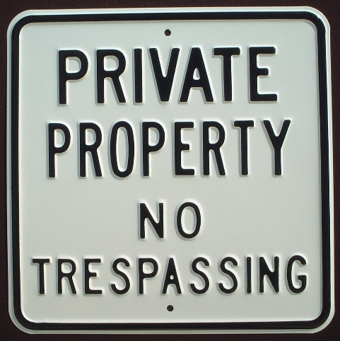
it didn’t say nothing
That side was made
for you and me

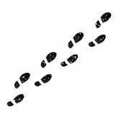
[Chorus]

I’ve roamed and rambled
And I followed my footsteps
To the sparkling sands of
Her diamond deserts
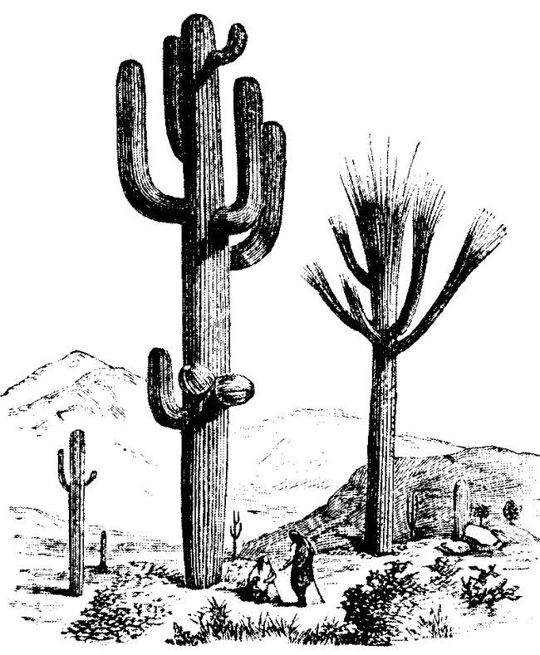
And all around me
a voice was sounding
This land was made
For you and me

[Chorus]
This Land is Your Land
by Woody Guthrie

This land is your land
This land is my land
From California
to the New York Island
From the redwood forest
to the Gulf Stream waters
This land was made
for you and me

[Chorus]

As I was walking
that ribbon of highway
I saw above me
that endless skyway
I saw below me
that golden valley
This land was made
for you and me

[Chorus]
As I was walking
I saw a sign there
And on the sign it said:
“NO TRESPASSING!”
But on the other side
it didn’t say nothing
That side was made
for you and me

[Chorus]

I’ve roamed and rambled
And I followed my footsteps
To the sparkling sands of
Her diamond deserts
And all around me
a voice was sounding
This land was made
For you and me

[Chorus]
This Land is Your Land
by Woody Guthrie

This land is your land
This land is my land
From California
to the New York Island
From the redwood forest
to the Gulf Stream waters
This land was made
for you and me

[Chorus]

As I was walking
that ribbon of highway
I saw above me
that endless skyway
I saw below me
that golden valley
This land was made
for you and me

[Chorus]
As I was walking
I saw a sign there
And on the sign it said:
“NO TRESPASSING!”
But on the other side
it didn’t say nothing
That side was made
for you and me

[Chorus]

I’ve roamed and rambled
And I followed my footsteps
To the sparkling sands of
Her diamond deserts
And all around me
a voice was sounding
This land was made
For you and me

[Chorus]
This Land is Your Land
by Woody Guthrie

This land is your land
This land is my land
From California
to the New York Island
From the redwood forest
to the Gulf Stream waters
This land was made
for you and me

[Chorus]

As I was walking
that ribbon of highway
I saw above me
that endless skyway
I saw below me
that golden valley
This land was made
for you and me

[Chorus]
As I was walking
I saw a sign there
And on the sign it said:
“NO TRESPASSING!”
But on the other side
it didn’t say nothing
That side was made
for you and me

[Chorus]

I’ve roamed and rambled
And I followed my footsteps
To the sparkling sands of
Her diamond deserts
And all around me
a voice was sounding
This land was made
For you and me

[Chorus]

