
Mother’s Day Song
by Edna Strauss

I have a little secret
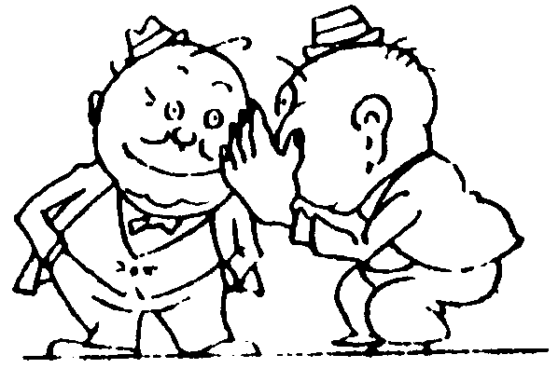
I’ll whisper in your ear
Mother’s Day is coming
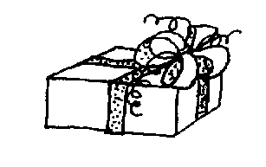
In fact, it’s almost here
I must make Mom a present
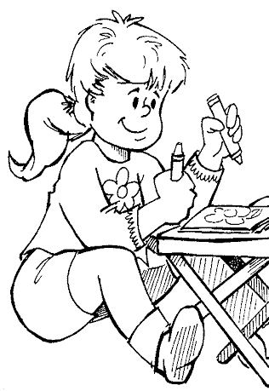
Just any gift won’t do
I’ll draw a pretty picture
That says “Mother, I love you”

So now you know my secret
Please keep it to yourself
My mom’s gift is finished
It’s hidden on a shelf
Then when I bring it to her
I know just what I’ll do
I’ll give my mom a great big hug
And tell her, “I love you”
Mother’s Day Song
by Edna Strauss

I have a little secret
I’ll whisper in your ear
Mother’s Day is coming
In fact, it’s almost here
I must make Mom a present
Just any gift won’t do
I’ll draw a pretty picture
That says “Mother, I love you”

So now you know my secret
Please keep it to yourself
My mom’s gift is finished
It’s hidden on a shelf
Then when I bring it to her
I know just what I’ll do
I’ll give my mom a great big hug
And tell her, “I love you”
Mother’s Day Song
by Edna Strauss

I have a little secret
I’ll whisper in your ear
Mother’s Day is coming
In fact, it’s almost here
I must make Mom a present
Just any gift won’t do
I’ll draw a pretty picture
That says “Mother, I love you”

So now you know my secret
Please keep it to yourself
My mom’s gift is finished
It’s hidden on a shelf
Then when I bring it to her
I know just what I’ll do
I’ll give my mom a great big hug
And tell her, “I love you”
Mother’s Day Song
by Edna Strauss

I have a little secret
I’ll whisper in your ear
Mother’s Day is coming
In fact, it’s almost here
I must make Mom a present
Just any gift won’t do
I’ll draw a pretty picture
That says “Mother, I love you”

So now you know my secret
Please keep it to yourself
My mom’s gift is finished
It’s hidden on a shelf
Then when I bring it to her
I know just what I’ll do
I’ll give my mom a great big hug
And tell her, “I love you”

