Home-Made Instrument Kit

Mini-Timpani / Drum Kit

Consists of:
2 sticks
6 clothespins

Pick two cans of different sizes. Rinse them out completely.
Make sure you safely remove one edge of each can with no rough edges.
Clip three clothes pins to the open end and turn upside down.
Decorate and begin playing.

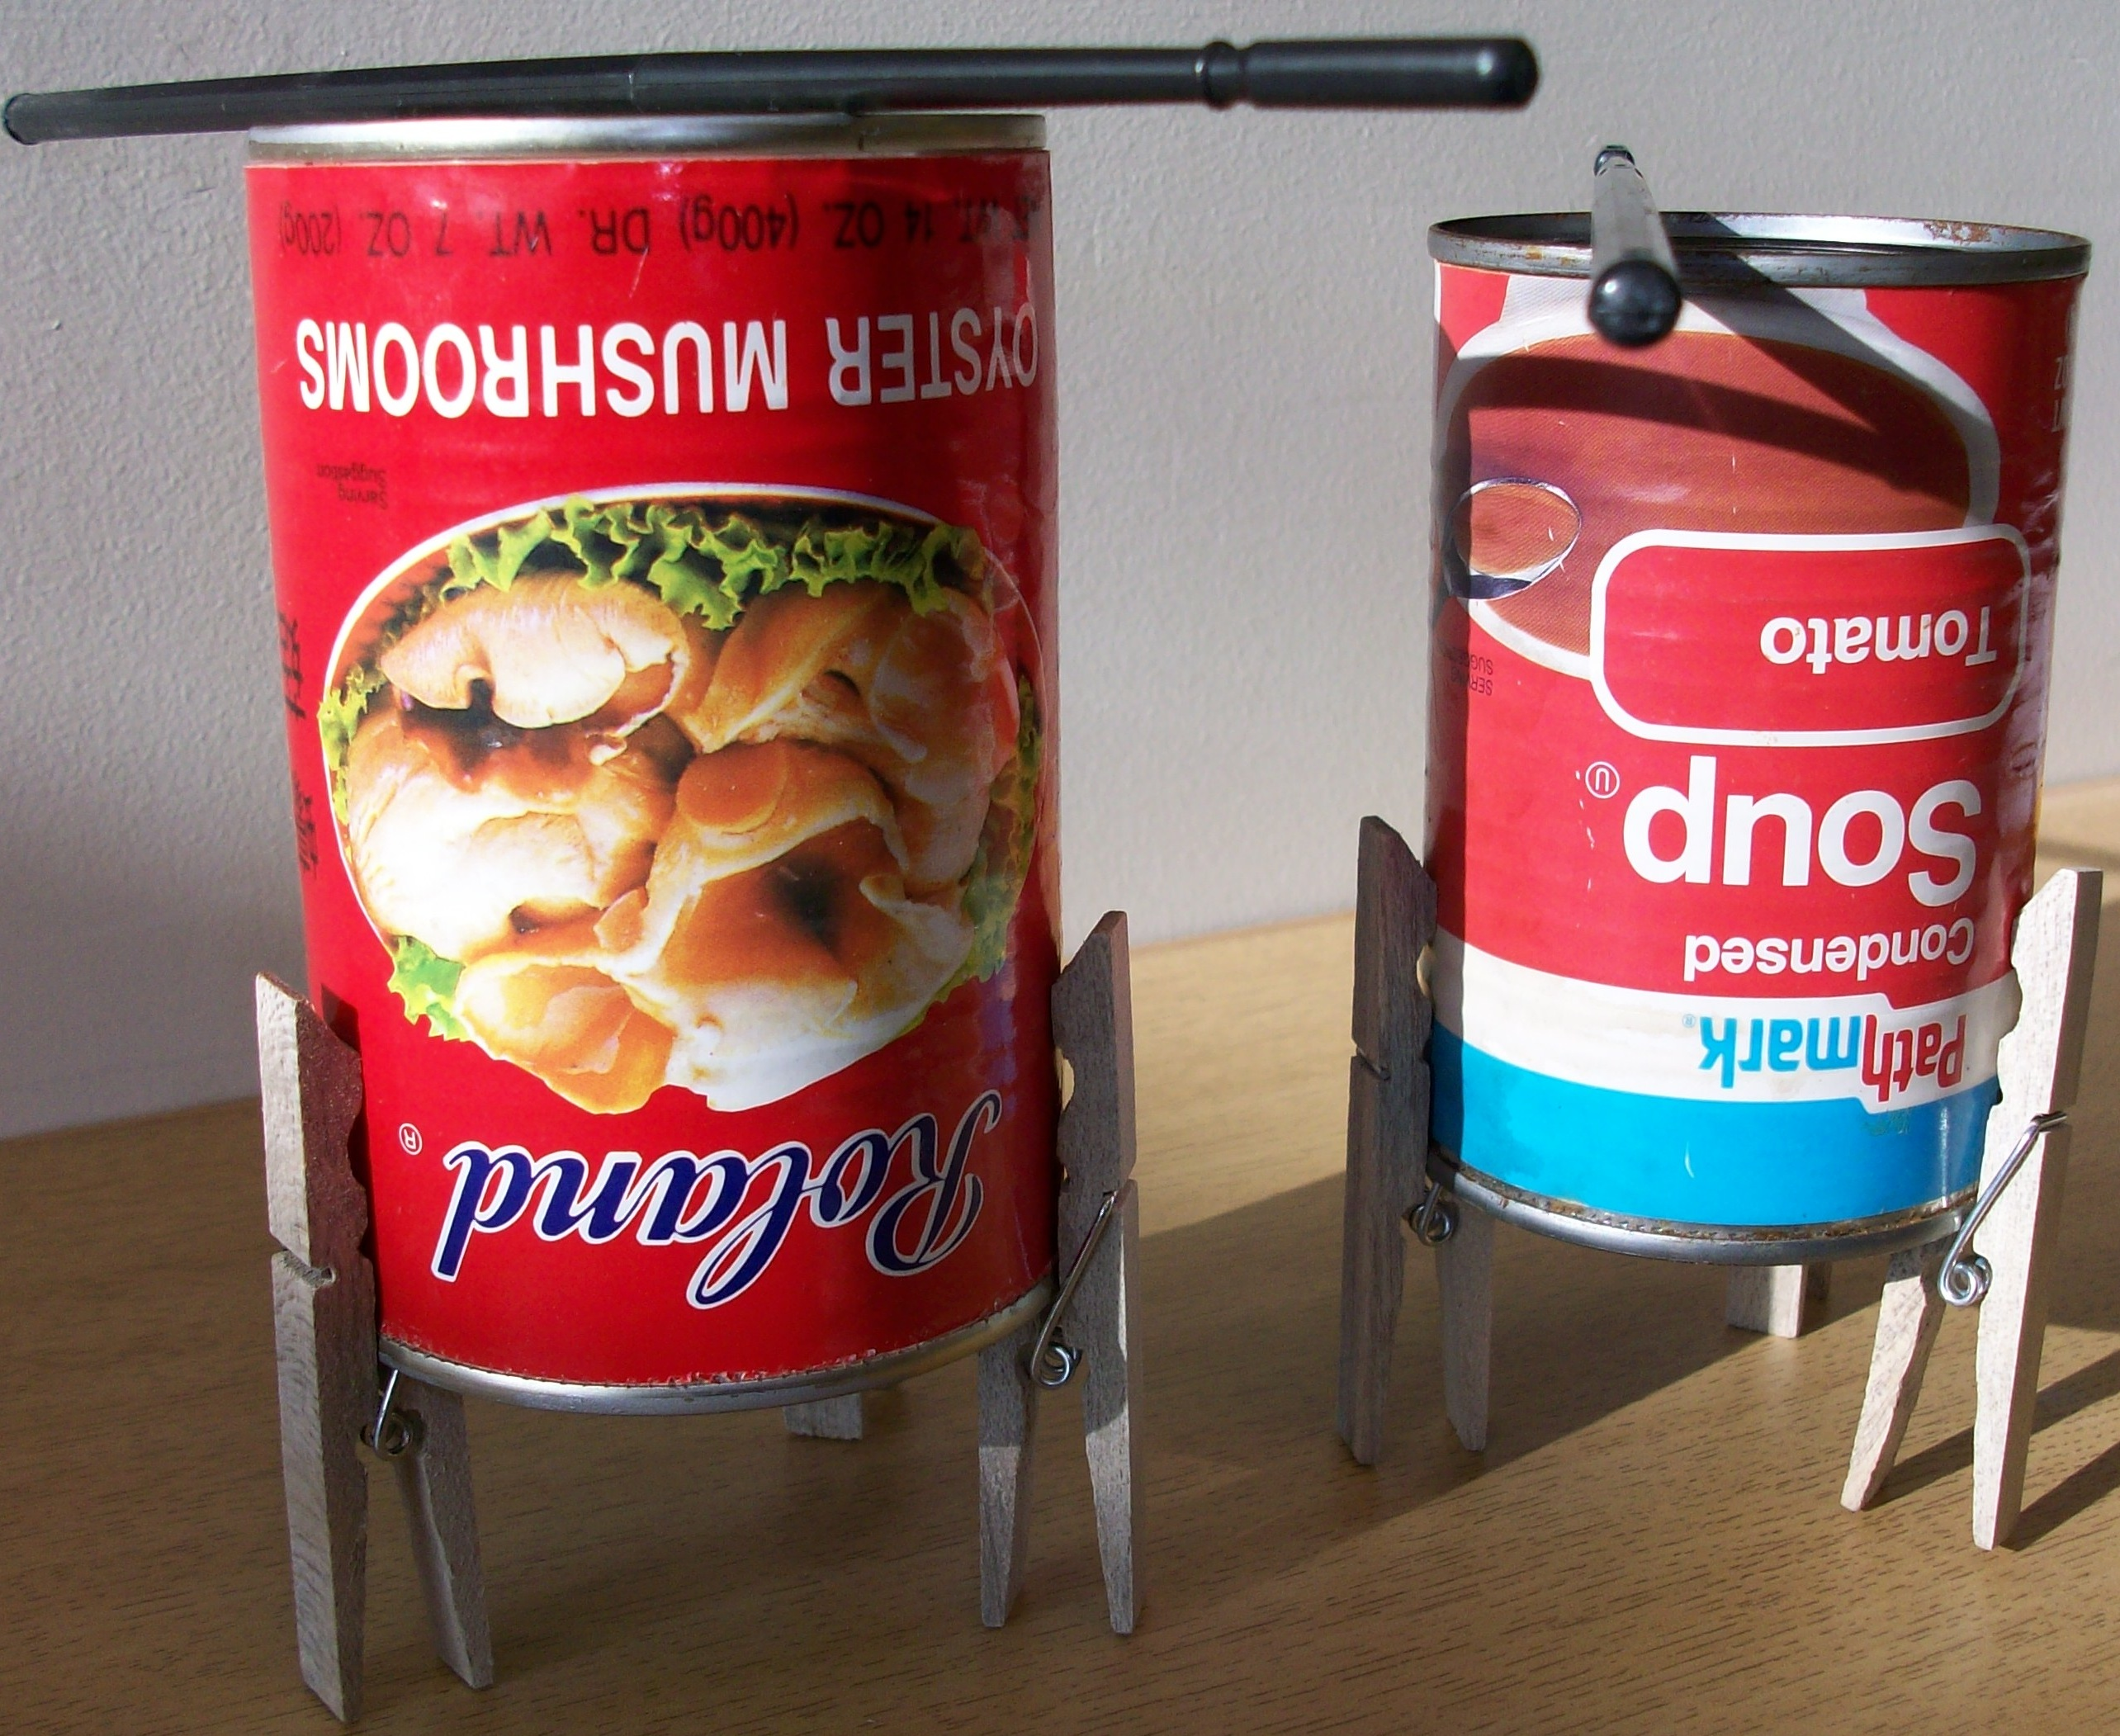

bashthetrash.com
corner189.com
Home-Made Instrument Kit

Mini-Timpani / Drum Kit

Consists of:
2 sticks
6 clothespins

Pick two cans of different sizes. Rinse them out completely.
Make sure you safely remove one edge of each can with no rough edges.
Clip three clothes pins to the open end and turn upside down.
Decorate and begin playing.

bashthetrash.com
corner189.com

