I Am a Pumpkin

I am a pumpkin, big and round
Once upon a time
I grew in the ground
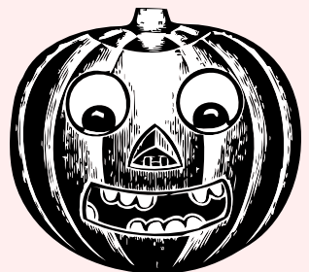
But now I have a mouth
two eyes and a nose
What are they for,
do you suppose?

When I have a candle
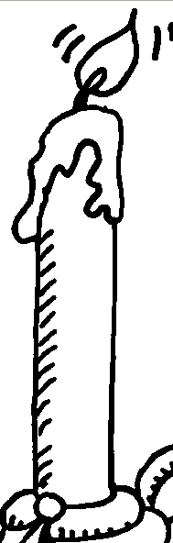
inside shining bright
I’ll be a jack-o-lantern
On Halloween night,
Halloween night!

I Am a Pumpkin

I am a pumpkin, big and round
Once upon a time
I grew in the ground
But now I have a mouth
two eyes and a nose
What are they for,
do you suppose?

When I have a candle
inside shining bright
I’ll be a jack-o-lantern
On Halloween night,
Halloween night!

I Am a Pumpkin

I am a pumpkin, big and round
Once upon a time
I grew in the ground
But now I have a mouth
two eyes and a nose
What are they for,
do you suppose?

When I have a candle
inside shining bright
I’ll be a jack-o-lantern
On Halloween night,
Halloween night!

I Am a Pumpkin

I am a pumpkin, big and round
Once upon a time
I grew in the ground
But now I have a mouth
two eyes and a nose
What are they for,
do you suppose?

When I have a candle
inside shining bright
I’ll be a jack-o-lantern
On Halloween night,
Halloween night!

I Am a Pumpkin

I am a pumpkin, big and round
Once upon a time
I grew in the ground
But now I have a mouth
two eyes and a nose
What are they for,
do you suppose?

When I have a candle
inside shining bright
I’ll be a jack-o-lantern
On Halloween night,
Halloween night!

I Am a Pumpkin

I am a pumpkin, big and round
Once upon a time
I grew in the ground
But now I have a mouth
two eyes and a nose
What are they for,
do you suppose?

When I have a candle
inside shining bright
I’ll be a jack-o-lantern
On Halloween night,
Halloween night!

