Bunny by the Woods
by Mr. Saphra
I caught a bunny by the woods
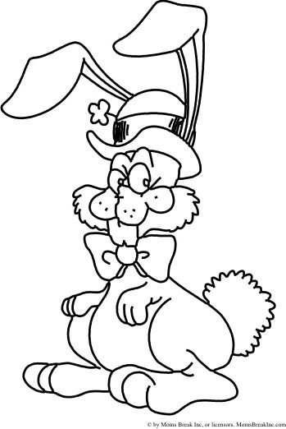
He hopped into my trap
I took him out
and stroked his coat
And put him in my lap
My little sister said to me,
“Why can’t we said him free?”
We need the Easter Bunny
To hide eggs for you and me!

