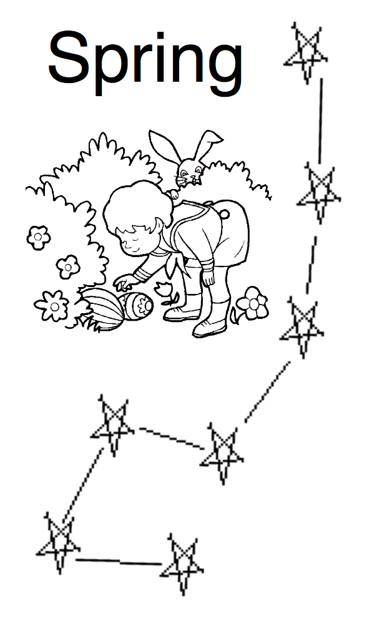
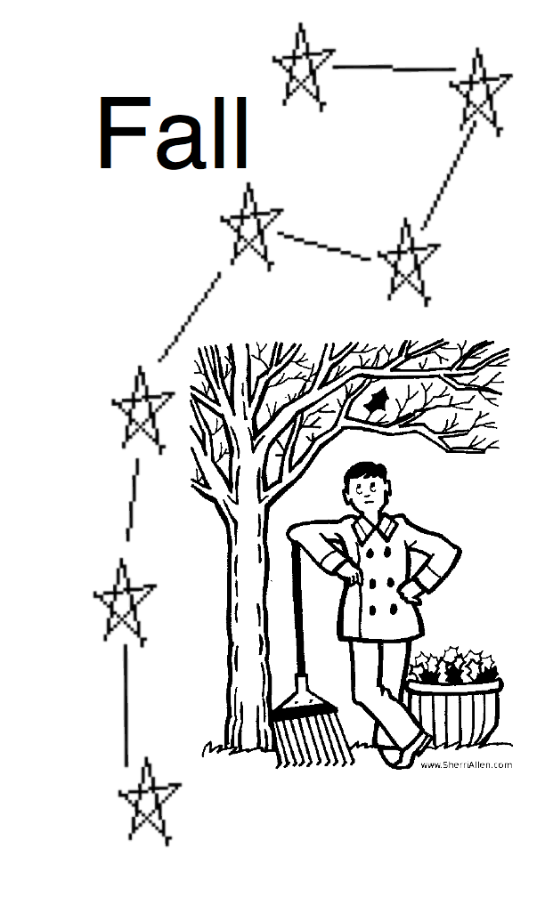
Name _____________________
Class ______________

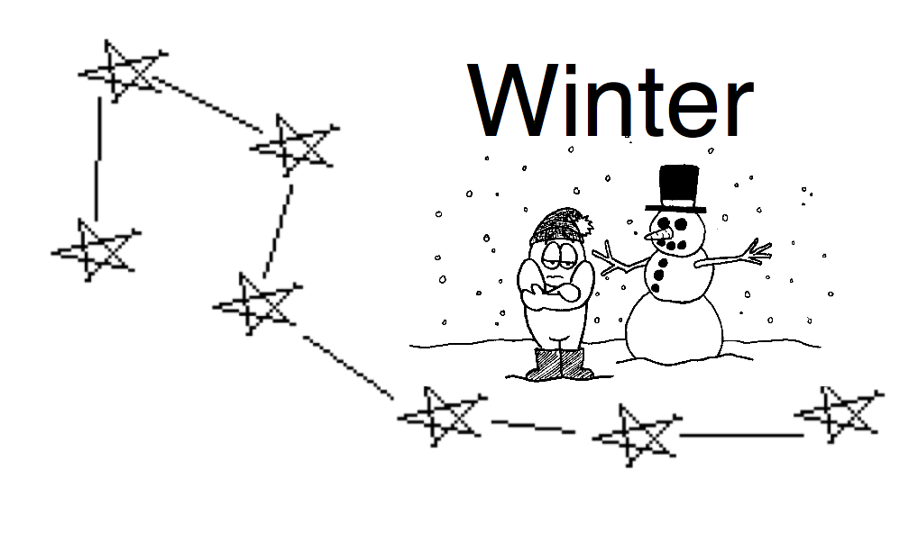

Directions:
1. Circle the two pointer stars in all four Big Dippers.
2. Draw a straight line away from the bowl of each
Big Dipper that is 6 times the distance between the two pointer stars.
3. At the end of each line, draw a 5-pointed star to show where Polaris is.
4. Label each of the four stars with the name of the season it belongs to.

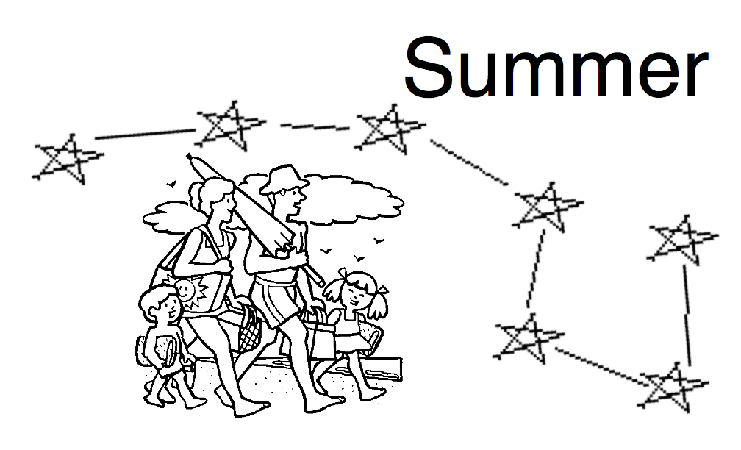

Name _____________________
Class ______________

Directions:
1. Circle the two pointer stars in all four Big Dippers.
2. Draw a straight line away from the bowl of each
Big Dipper that is 6 times the distance between the two pointer stars.
3. At the end of each line, draw a 5-pointed star to show where Polaris is.
4. Label each of the four stars with the name of the season it belongs to.

Name _____________________
Class ______________

Directions:
1. Circle the two pointer stars in all four Big Dippers.
2. Draw a straight line away from the bowl of each
Big Dipper that is 6 times the distance between the two pointer stars.
3. At the end of each line, draw a 5-pointed star to show where Polaris is.
4. Label each of the four stars with the name of the season it belongs to.

Name _____________________
Class ______________

Directions:
1. Circle the two pointer stars in all four Big Dippers.
2. Draw a straight line away from the bowl of each
Big Dipper that is 6 times the distance between the two pointer stars.
3. At the end of each line, draw a 5-pointed star to show where Polaris is.
4. Label each of the four stars with the name of the season it belongs to.

