FOLLOW THE DRINKING GOURD
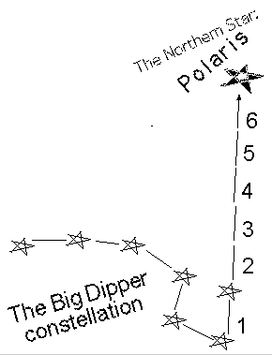
(Song of the Underground Railroad)

Follow the drinking gourd
Follow the drinking gourd
For the old man is a-waiting
For to carry you to freedom
Follow the drinking gourd

Follow the star to the North
Follow the star to the North
For the old man is a-waiting
For to carry you to freedom
Follow the drinking gourd

Follow the drinking gourd …

Follow the secret way out
Follow the secret way out
For the old man is a-waiting
For to carry you to freedom
Follow the drinking gourd

Follow the drinking gourd …

Follow the drinking gourd …

