Name _____________________
Class ______________

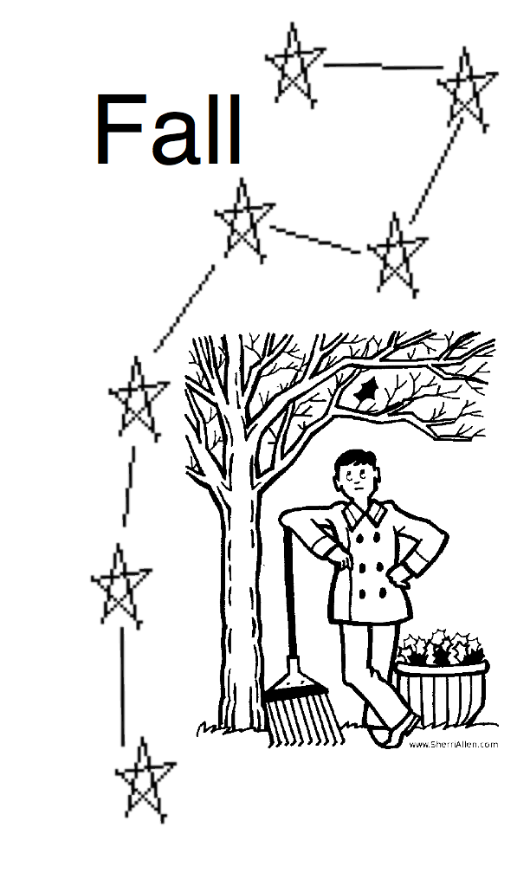
Name _____________________
Class ______________

Name _____________________
Class ______________

Name _____________________
Class ______________

Name _____________________
Class ______________

Name _____________________
Class ______________

Name _____________________
Class ______________

Name _____________________
Class ______________

