Cockles and Mussels – Irish Song
In Dublin's fair city
Where girls are so pretty
‘Twas there that I first met
Miss Molly Malone
She wheels her wheelbarrow
Through streets broad
and narrow
Crying, "Cockles and mussels,
Alive, alive oh"

Alive, alive oh,
Alive, alive oh,
Crying, "Cockles and mussels,
Alive, alive oh"
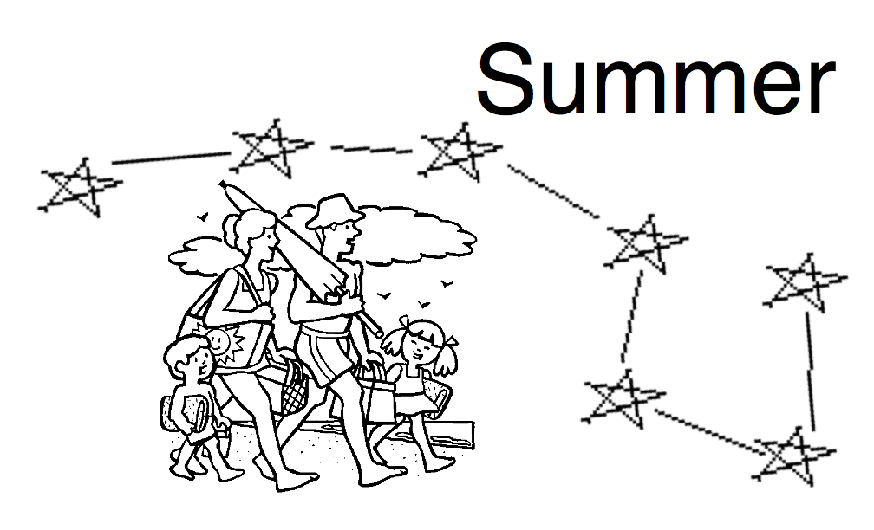

Cockles and Mussels – Irish Song
In Dublin's fair city
Where girls are so pretty
‘Twas there that I first met
Miss Molly Malone
She wheels her wheelbarrow
Through streets broad
and narrow
Crying, "Cockles and mussels,
Alive, alive oh"

Alive, alive oh,
Alive, alive oh,
Crying, "Cockles and mussels,
Alive, alive oh"

Cockles and Mussels – Irish Song
In Dublin's fair city
Where girls are so pretty
‘Twas there that I first met
Miss Molly Malone
She wheels her wheelbarrow
Through streets broad
and narrow
Crying, "Cockles and mussels,
Alive, alive oh"

Alive, alive oh,
Alive, alive oh,
Crying, "Cockles and mussels,
Alive, alive oh"

Cockles and Mussels – Irish Song
In Dublin's fair city
Where girls are so pretty
‘Twas there that I first met
Miss Molly Malone
She wheels her wheelbarrow
Through streets broad
and narrow
Crying, "Cockles and mussels,
Alive, alive oh"

Alive, alive oh,
Alive, alive oh,
Crying, "Cockles and mussels,
Alive, alive oh"

