Reduce, Reuse Recycle – 3 R Song
by Jack Johnson

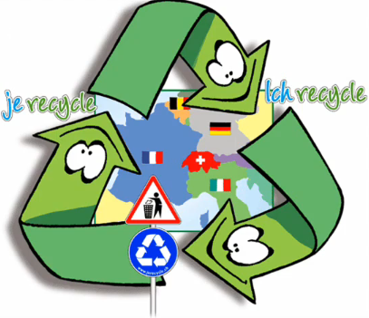
Three, that's the magic number
Yes it is, it's a magic number
Two times three is six
And three times six is eighteen
And the eighteenth letter
in the alphabet is "R"
There's three R's
we're going to talk about today

You've got to learn to
REDUCE, REUSE, RECYCLE
REDUCE, REUSE, RECYCLE
REDUCE, REUSE, RECYCLE
REDUCE, REUSE, RECYCLE

If you're going to the market
to buy some juice
Bring some bags and you learn
to REDUCE your waste
Got to reduce your waste
And if you're brother or your
sister's got some cool clothes
Try them on before you
buy some more of those,
REUSE
You've got to learn to reuse

And if the first two "R's"
don't work out
And you've got to make some trash
Don't throw it out, RECYCLE
You've got learn to recycle

You've got to learn to
REDUCE, REUSE, RECYCLE
REDUCE, REUSE, RECYCLE
REDUCE, REUSE, RECYCLE
REDUCE, REUSE, RECYCLE

'Cause three that's the magic number
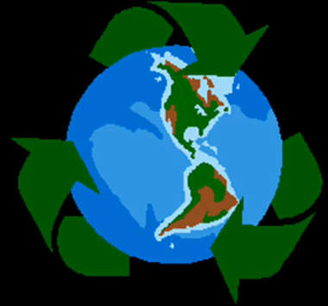
Yes it is, it's a magic number

Reduce, Reuse Recycle – 3 R Song
by Jack Johnson

Three, that's the magic number
Yes it is, it's a magic number
Two times three is six
And three times six is eighteen
And the eighteenth letter
in the alphabet is "R"
There's three R's
we're going to talk about today

You've got to learn to
REDUCE, REUSE, RECYCLE
REDUCE, REUSE, RECYCLE
REDUCE, REUSE, RECYCLE
REDUCE, REUSE, RECYCLE

If you're going to the market
to buy some juice
Bring some bags and you learn
to REDUCE your waste
Got to reduce your waste
And if you're brother or your
sister's got some cool clothes
Try them on before you
buy some more of those,
REUSE
You've got to learn to reuse

And if the first two "R's"
don't work out
And you've got to make some trash
Don't throw it out, RECYCLE
You've got learn to recycle

You've got to learn to
REDUCE, REUSE, RECYCLE
REDUCE, REUSE, RECYCLE
REDUCE, REUSE, RECYCLE
REDUCE, REUSE, RECYCLE

'Cause three that's the magic number
Yes it is, it's a magic number

Reduce, Reuse Recycle – 3 R Song
by Jack Johnson

Three, that's the magic number
Yes it is, it's a magic number
Two times three is six
And three times six is eighteen
And the eighteenth letter
in the alphabet is "R"
There's three R's
we're going to talk about today

You've got to learn to
REDUCE, REUSE, RECYCLE
REDUCE, REUSE, RECYCLE
REDUCE, REUSE, RECYCLE
REDUCE, REUSE, RECYCLE

If you're going to the market
to buy some juice
Bring some bags and you learn
to REDUCE your waste
Got to reduce your waste
And if you're brother or your
sister's got some cool clothes
Try them on before you
buy some more of those,
REUSE
You've got to learn to reuse

And if the first two "R's"
don't work out
And you've got to make some trash
Don't throw it out, RECYCLE
You've got learn to recycle

You've got to learn to
REDUCE, REUSE, RECYCLE
REDUCE, REUSE, RECYCLE
REDUCE, REUSE, RECYCLE
REDUCE, REUSE, RECYCLE

'Cause three that's the magic number
Yes it is, it's a magic number

Reduce, Reuse Recycle – 3 R Song
by Jack Johnson

Three, that's the magic number
Yes it is, it's a magic number
Two times three is six
And three times six is eighteen
And the eighteenth letter
in the alphabet is "R"
There's three R's
we're going to talk about today

You've got to learn to
REDUCE, REUSE, RECYCLE
REDUCE, REUSE, RECYCLE
REDUCE, REUSE, RECYCLE
REDUCE, REUSE, RECYCLE

If you're going to the market
to buy some juice
Bring some bags and you learn
to REDUCE your waste
Got to reduce your waste
And if you're brother or your
sister's got some cool clothes
Try them on before you
buy some more of those,
REUSE
You've got to learn to reuse

And if the first two "R's"
don't work out
And you've got to make some trash
Don't throw it out, RECYCLE
You've got learn to recycle

You've got to learn to
REDUCE, REUSE, RECYCLE
REDUCE, REUSE, RECYCLE
REDUCE, REUSE, RECYCLE
REDUCE, REUSE, RECYCLE

'Cause three that's the magic number
Yes it is, it's a magic number

