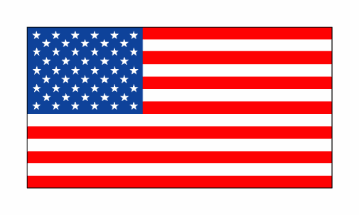
The Star-Spangled Banner

Sir Francis Scott Key, 1814

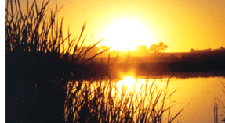
Oh, say can you see
by the dawn's early light
What so proudly we hailed
at the twilight's last gleaming?
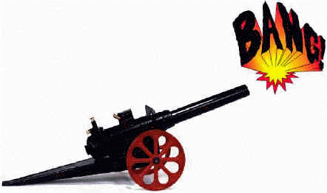
Whose broad stripes
and bright stars
Through the perilous fight,
O'er the ramparts we watched
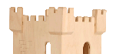
were so gallantly streaming?
And the rocket's red glare,
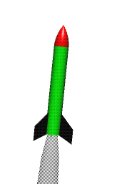
the bombs bursting in air,
Gave proof through the night

that our flag was still there.

Oh, say does that star-spangled
banner yet wave
O'er the land of the free
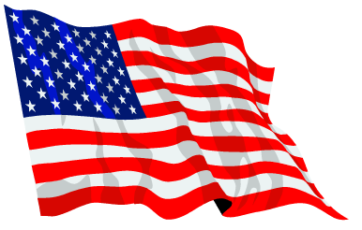
and the home of the brave?

