MUST BE SANTA

Who's got a beard that's long and white?
Santa's got a beard that's long and white.
Who comes around on a special night?
Santa comes around on a special night.

Special night, beard that's white,
Must be Santa must be Santa,
Must be Santa, Santa Claus.

Who wears boots and a suit of red? Who wears boots and a suit of red?

Who wears a long cap on his head?
Santa wears a long cap on his head.
Cap on head, suit that's red,
Special night, beard that's white,
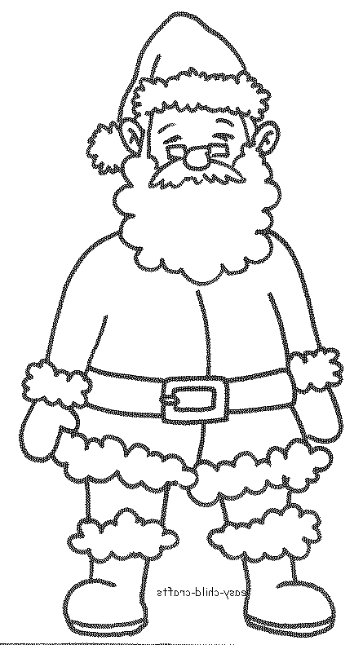
Must be Santa must be Santa,
Must be Santa, Santa Claus.

Who's got a big red cherry nose?
Santa's got a big red cherry nose.
Who laughs this way: HO HO HO?
Santa laughs this way: HO HO HO!

HO HO HO’s, cherry nose,
Cap on head, suit that's red,
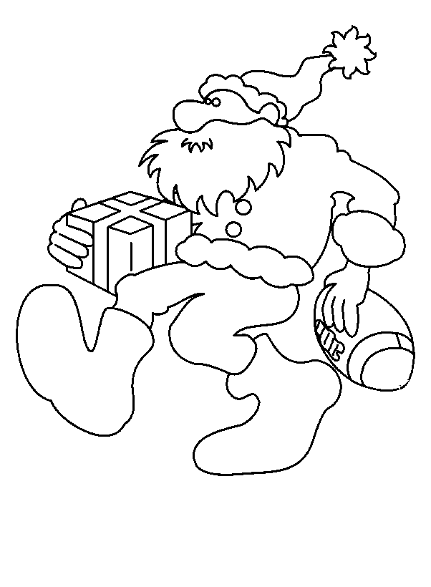
Special night, beard that's white,

Must be Santa must be Santa,
Must be Santa, Santa Claus.

Who very soon will come our way?
Santa very soon will come our way.

Eight little reindeer pull his sleigh,
Santa's little reindeer pull his sleigh.

Reindeer sleigh, come our way,
HO HO HO’s, cherry nose,

Cap on head, suit that's red,
Special night, beard that's white,

Must be Santa, must be Santa,
Must be Santa, Santa Claus.

||: Dasher, Dancer, Prancer, Vixen, Comet, Cupid, Donner and Blitzen :||

Reindeer sleigh, come our way,
HO HO HO, cherry nose,
Cap on head, suit that's red,
Special night, beard that's white,

Must be Santa, must be Santa,
Must be Santa, Santa Claus!

