Outside of a dog, a book is man's best friend.
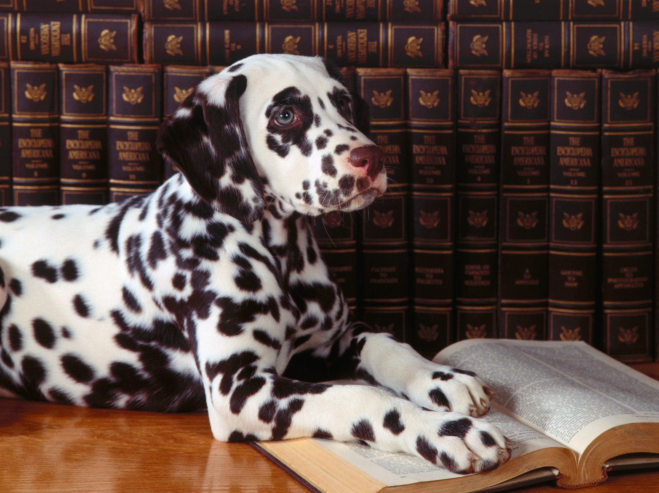

Groucho
Marx quote
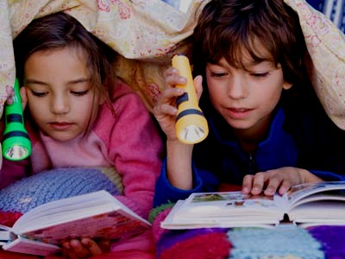

Inside of a dog it's too dark to read.

