Outside of a dog, a book is man's best friend.

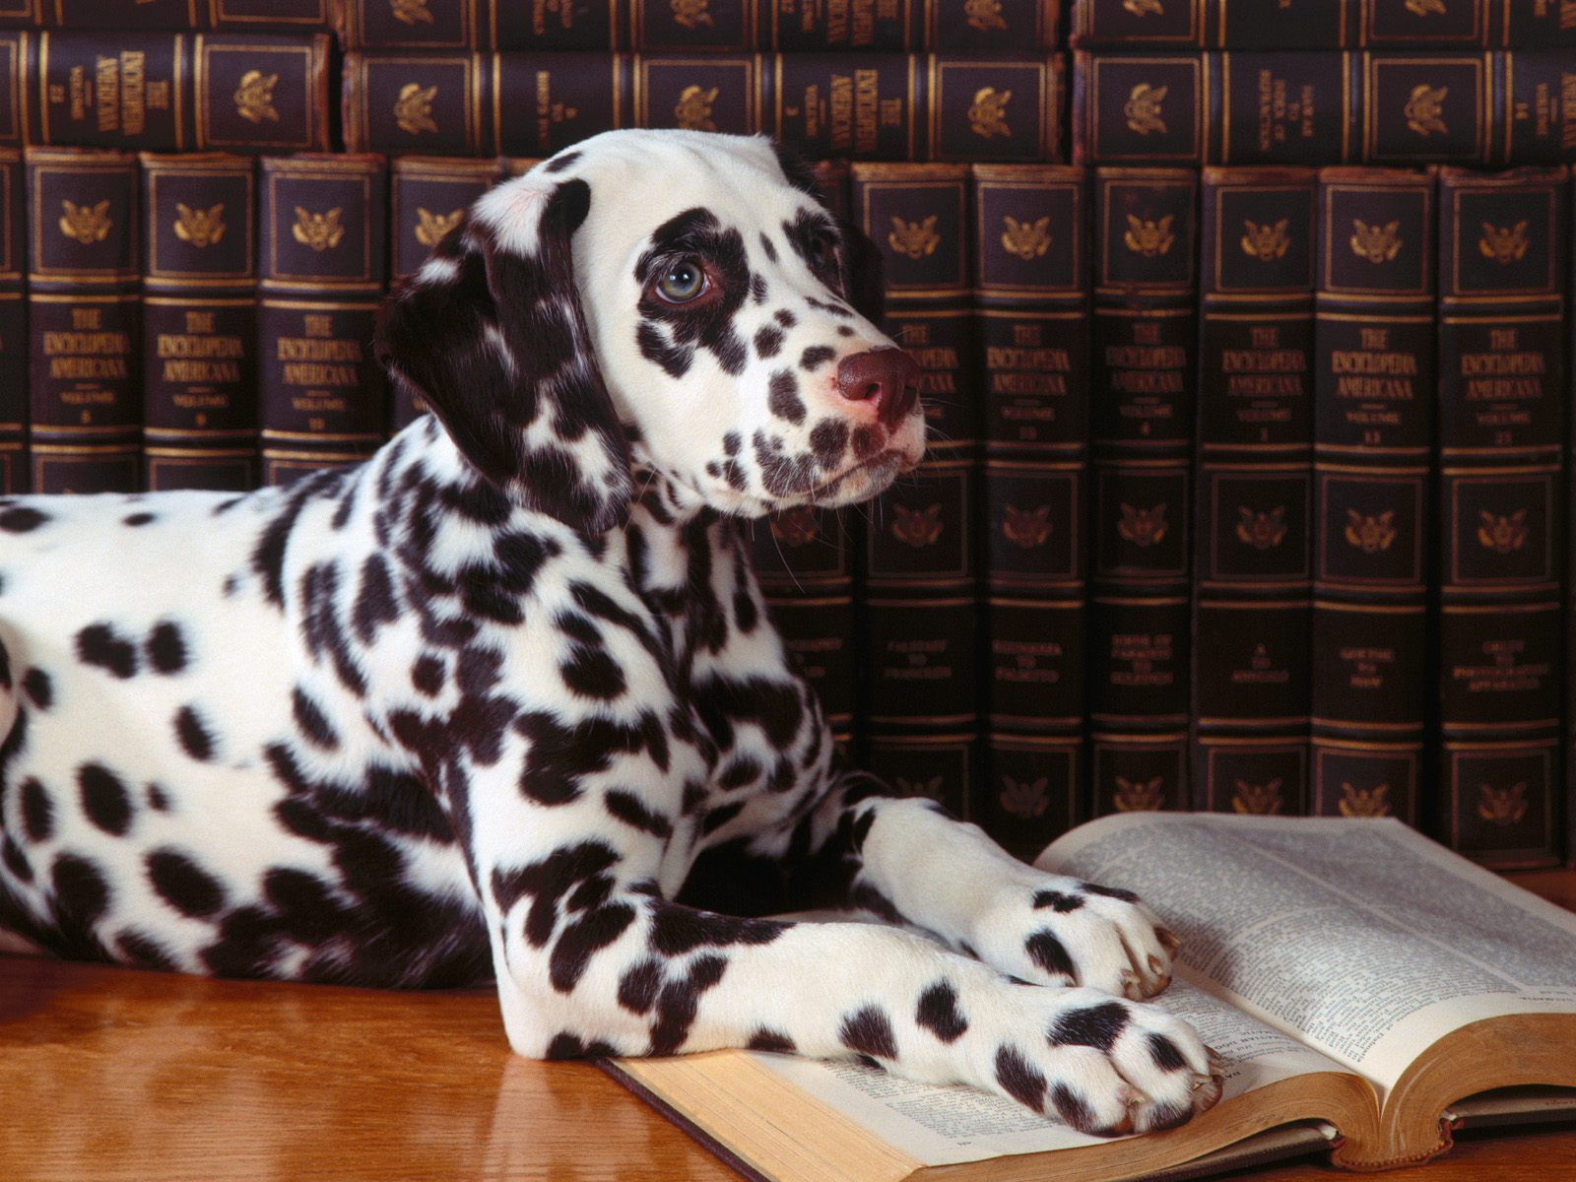


Groucho
Marx quote

Inside of a dog it's too dark to read.

