I Am a Pumpkin
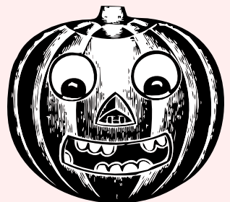

I am a pumpkin,
big and round
Once upon a time
I grew in the ground
But now I have a mouth,
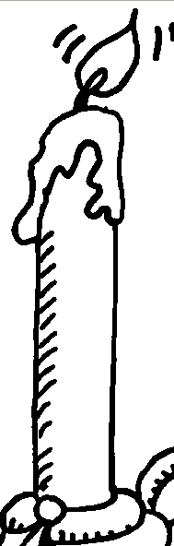
two eyes and a nose
What are they for
do you suppose?
When I have a candle
inside shining bright
I’ll be a jack-o-lantern
On Halloween night,
Halloween night!

