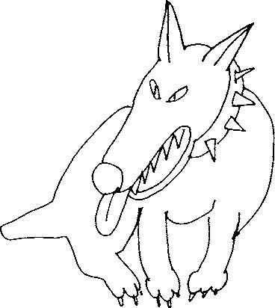
Great Big Dog

Lullaby

Great Big Dog
went out on the meadow
Shook his tail
and shook the meadow
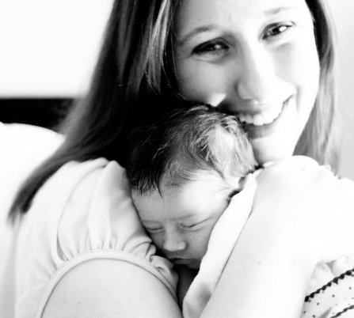
||: Go away, dog,
go away dog
You can’t have
my baby :||

