Go Out and Vote
What would you think
if you threw a party
and nobody came?
Would you stand there
moping all alone?
Would you wonder
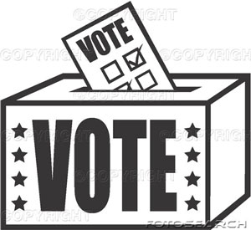
who’s to blame?
Now, here’s an invitation
To the biggest bash
in the nation
November 3rd’s Election Day
So let’s all have a ball:
Go out and vote
Go out and vote
Grab your hat,
Put on your coat
Go out and vote

You may think that
Every little thing’s O.K.
Or you may think
there’s no hope
Forget all that
Just grab your hat
And go out and vote

