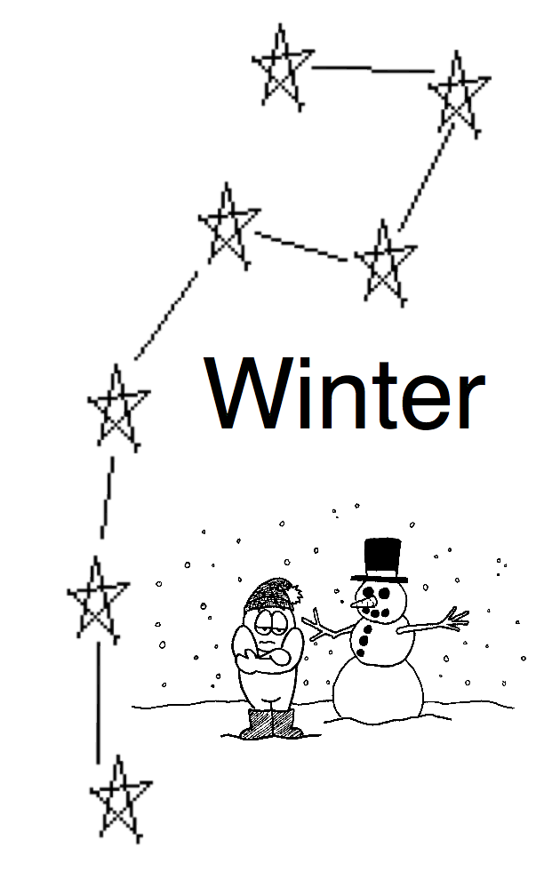
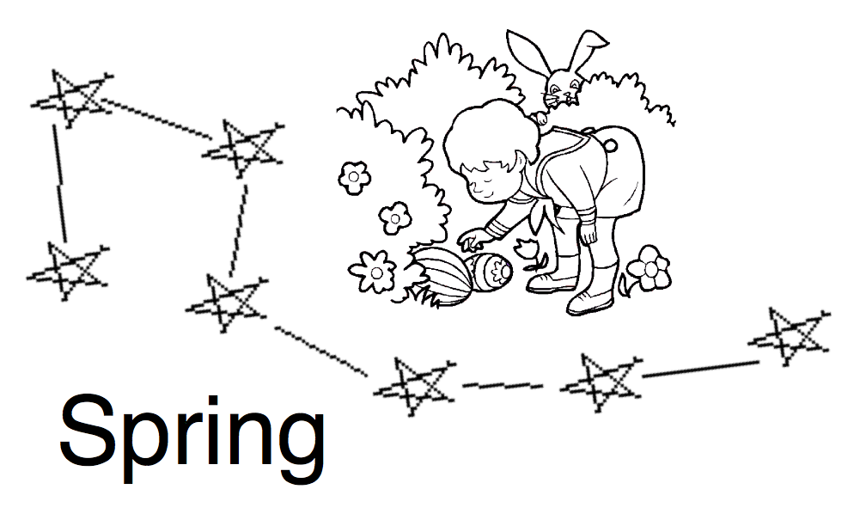
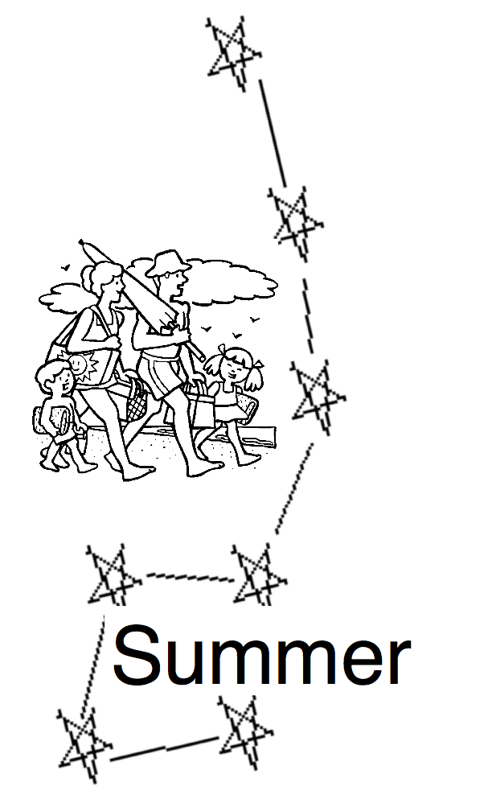
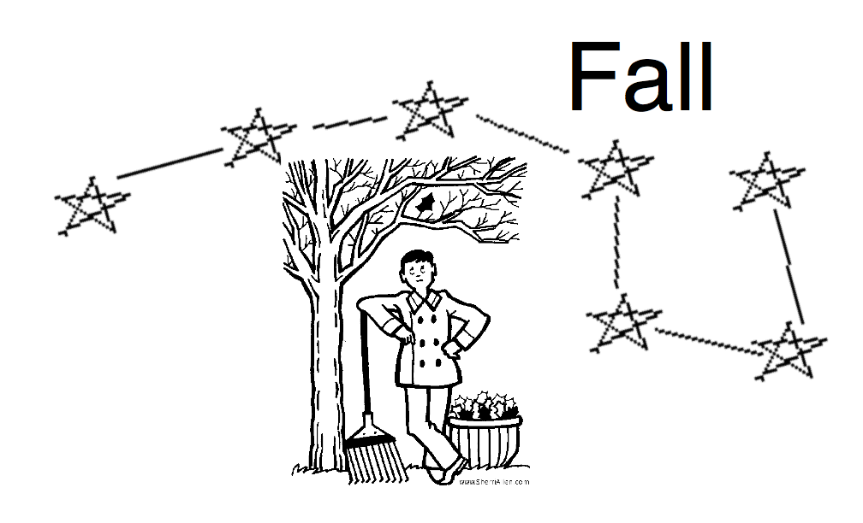
Name ________________
Directions: Draw a line for each season 6 times the distance between the two pointer stars in the big dipper. At the end of each line, draw the star Polaris and label each of the four seasons next to the stars.

