August 28, 2009
To: All Educators
From: Malissa Mootoo
Re: Environment Expectations Checklist

Below you will find a table that explains certain classroom environment non-negotiable components. The table also outlines the criterion and examples for each component. Eventually it is my hope that I will be able to include photographs from our classrooms—I didn’t have a chance this year. All teachers will be expected to adhere to the environment expectations.
*Check box as task is completed.

Non-negotiable Components | Criteria | Examples
CASA Specific Items | - The CASA Core Values and Rules must be posted  - Student and teacher personal codes should be posted and revised  - The CASA Universal Grading Criteria must be posted in the room | See CASA Staff Handbook
Classroom Behavior Management | - Clear and easy to read system for tracking student behavior  - Visitors can easily tell how students are performing  - If you do not currently have a system that works well, and is evident to anyone entering the room, you are to use the CASA color coded system of green, yellow, orange, red | 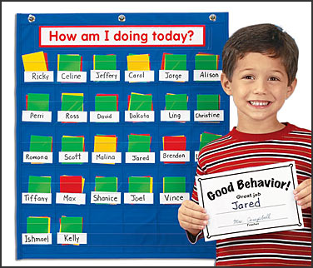
Classroom Responsibility Chart (Job Chart) | - Chart includes student responsibilities and/or job (grade-specific) clearly stated for example: Line leader, door holder etc. | 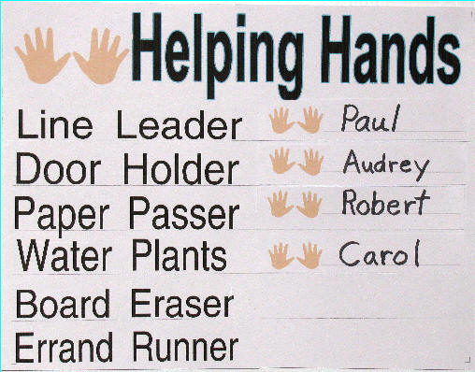
Peace Place | - Used as a reflection area for redemption, cool down, and self-reflection  - Space is labeled  - Contains necessary materials | 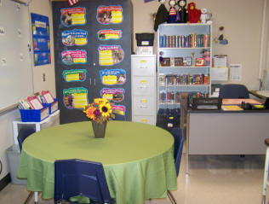
Door Display | - Name of class is prominently displayed  - Accurate program card is displayed  - Current Monthly Curriculum Sign is displayed | Class name example: 4-Union  Program card was provided for you in an electronic fashion
Room Organization | - Classroom is neat and clean  - Free of clutter (especially piles of paper)  - A basket is designated for reusable paper for classroom use  - A recycling bin is used daily for paper recycling only | 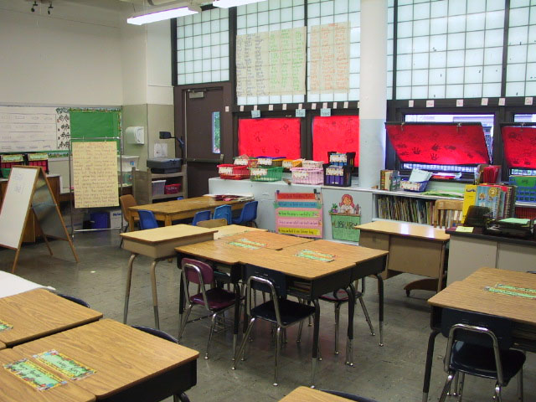
Desk Arrangement | - Desks are arranged in cooperative groups of 2-4  - Students can easily access all information  - Students are able to transition easily | 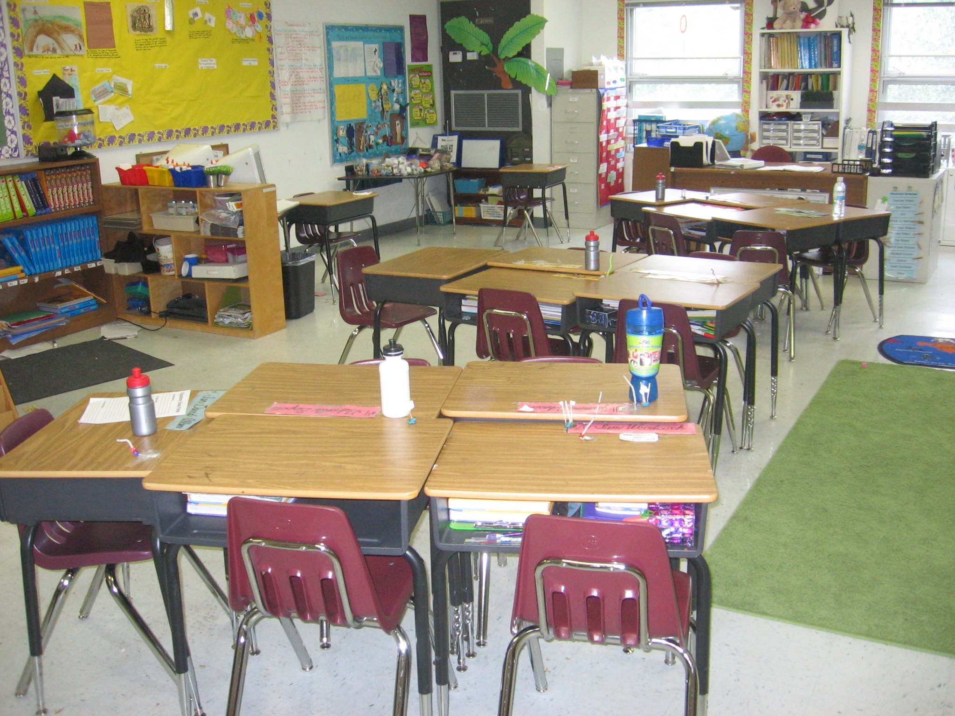
Classroom Libraries | - Baskets clearly labeled with levels and/or genres (visuals may also be used)  - Labels facing forward  - Leveled library has each basket labeled by level  - Books are arranged and organized neatly | 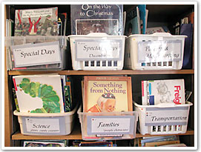
Content Area Arrangement | - The center for each content area is clearly labeled  - Essential questions for the unit are posted  - Books from current units of study are prominently displayed  - Books are arranged based on content areas | 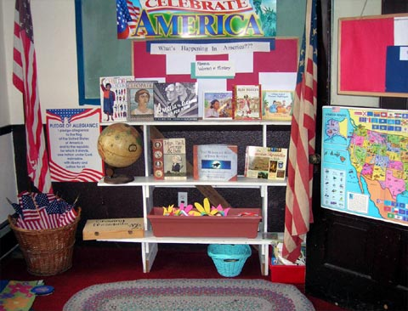
Math Manipulatives | - Clearly labeled baskets  - Labels facing outward | 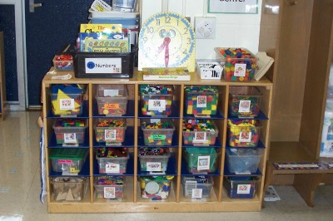
Flow of the Day | - Each component of the day is displayed  - Font large enough for students to see  - Younger grades should use pictures  - All grades are expected to have a grade appropriate times next to each component  - The flow of the day needs to be adhered to so that students are receiving instruction in all content areas for the number of designated minutes (one best practice that helps this is using a timer) | 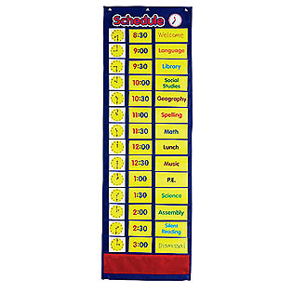  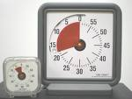
Inside Bulletin Boards | - Each content area has a specific bulletin board to display current student work  - A board and/or section for Citizen of the Month students, Book of the Month and/or Words of Wisdom  - Title and blurb explaining the work posted  - Work changed on a monthly basis  - Clearly labeled/titled with teacher name, date and class  - Work has some form of teacher feedback, comments, and/or numeric value | 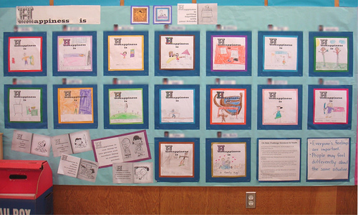  Missing teacher feedback  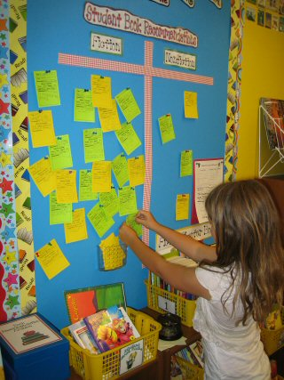  Interactive bulletin board
Student Work | - Student work reflects current units of study or one that just ended  - Blurbs explain student work and units of study  - Teacher feedback and/or comments | 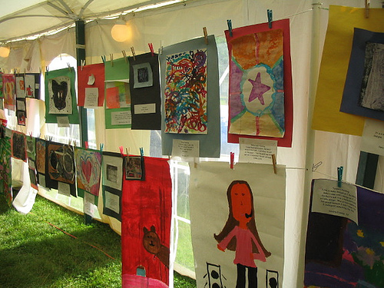  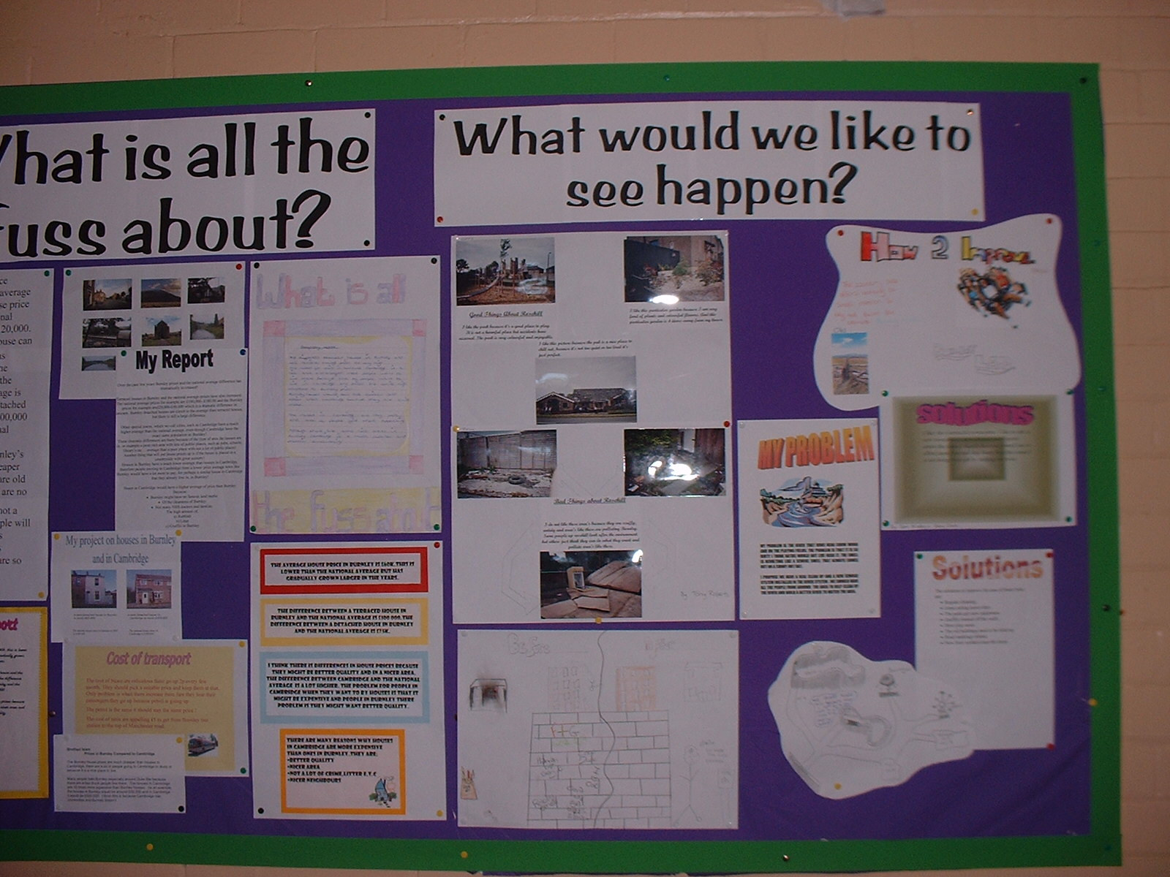
Word Wall | - Interactive  - Updated regularly and made current  - Appropriate size, words large enough for all students to see. | 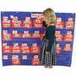  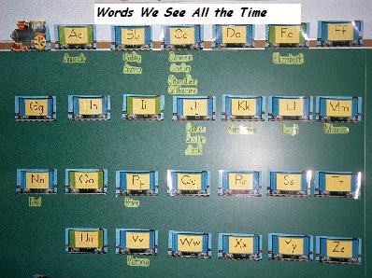
Charts | - Purposeful and related to current topics (they should not be used as wall paper)  - Font big enough for students to read  - Balance between teacher/student created and store bought  - All corners of the charts are stuck to the wall  - Neat and organized charts | 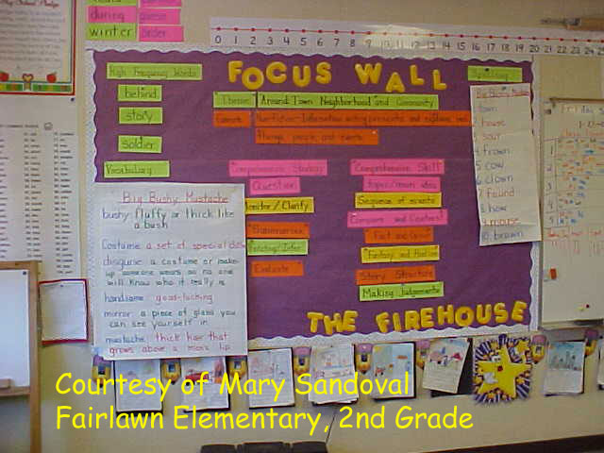
Outside Bulletin Boards | - Changed by the first Thursday of every month  - Grade level and content area appropriate standards-based work is displayed  - At least 80% of students have work represented by all levels  - Blurb explaining the work posted  - Standards posted  - Clearly labeled/titled  - Work has quality feedback and/or comments (at least 1 positive and 1 next step)  - All work is dated | 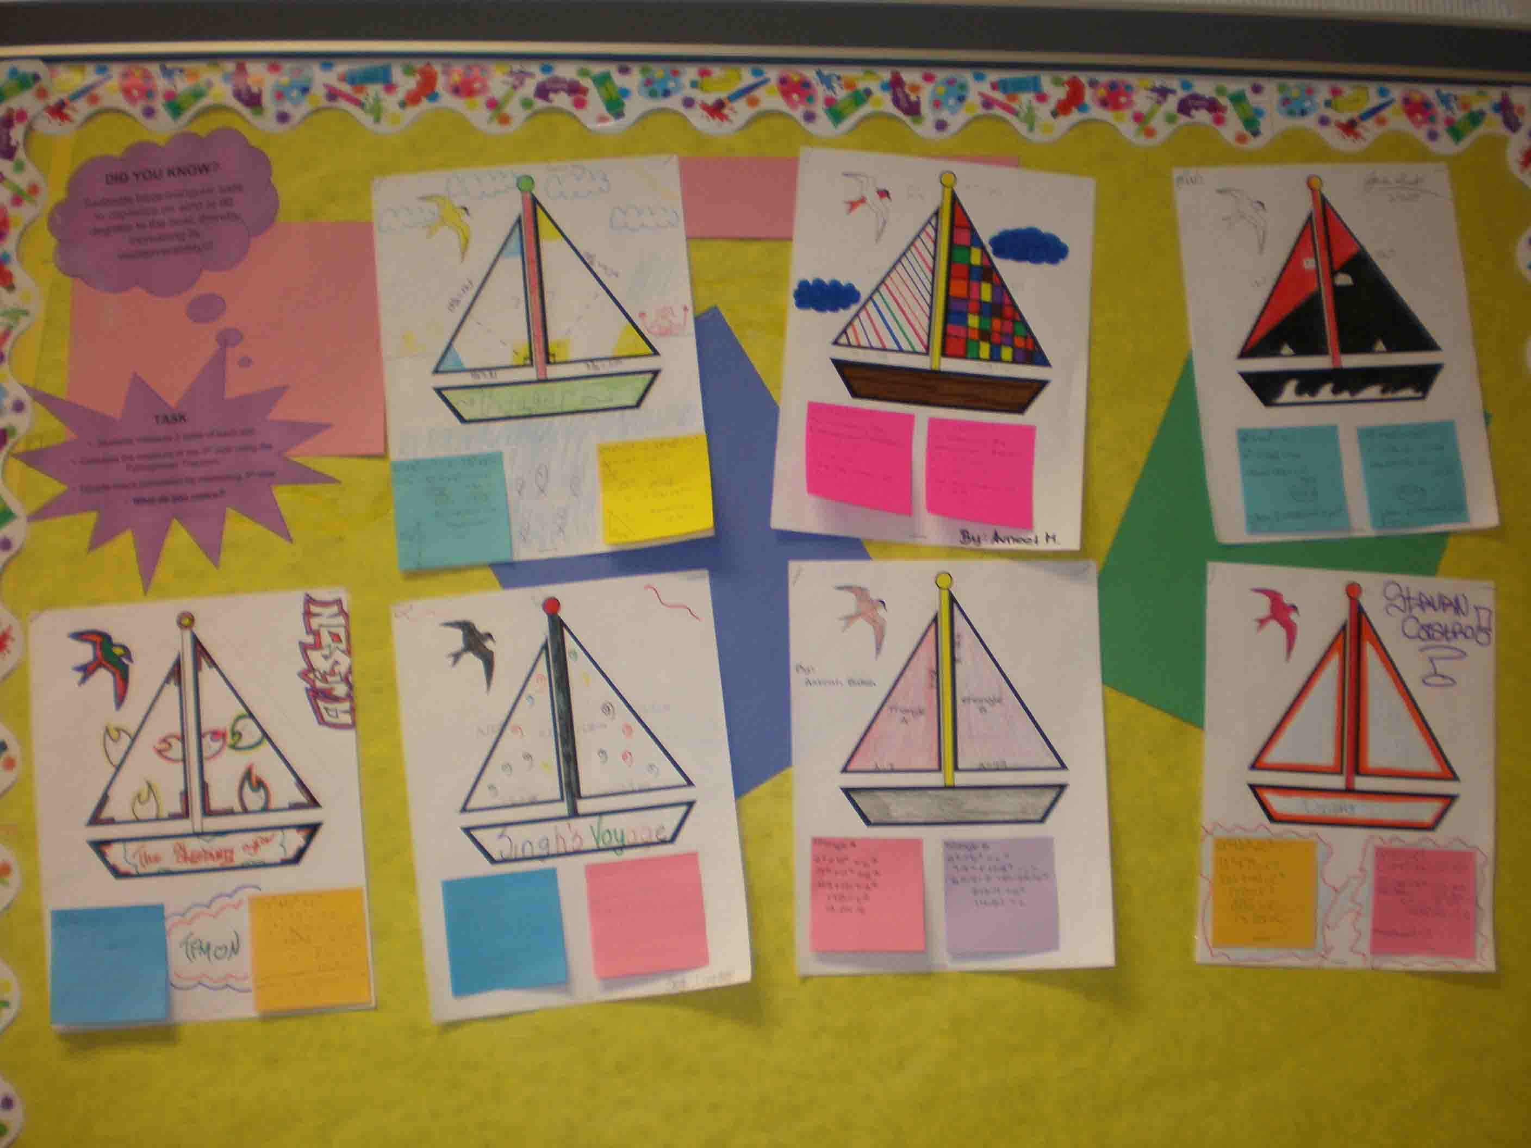  Teacher comments included
Hall Passes & Sign-out Book | - Hall passes and sign-out book are next to the exit  - Hall passes indicate room  - Sign out book has the following components: date, name, sign-out time, sign-in time, destination | 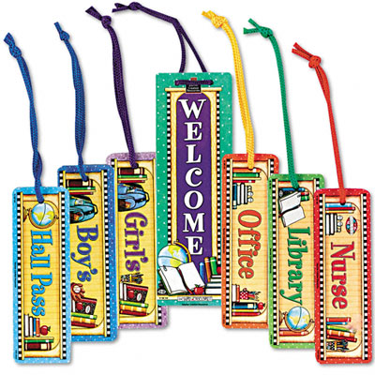
Data Binders | - Designate a specific area to display Data Binders  - Area is clearly labeled and visible to all
Substitiute Teacher Information | - Clearly labeled basket where sub-folder will be placed  - For specifics as to what needs to be included in the folder please refer to Substitute Teacher Memo  - Duplicate folder approved by Supervisor needs to be placed in the main office

