There Was a Man
by Edna Strauss

There was a man, a gentle man
Who gave up his life for his land
He reached out his hand
to touch every heart
For he knew that we’d understand
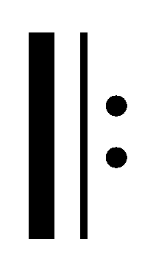
This man had a dream
That someday for all
The bells of freedom ring
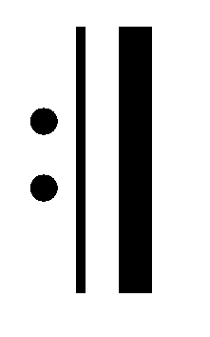
His dream will become reality
For his name is Martin Luther King

Martin Luther King
by Theresa Fullbright

He wanted peace and love all over this land
He wanted peace and love all over this land
Martin Luther King was a peace-loving man
He wanted peace and love all over this land

He walked for you and me all over this land
He walked for you and me all over this land
Martin Luther King was a great, great man
He walked for you and me all over this land

He died for freedom’s cause to save this land
He died for freedom’s cause to save this land
Martin Luther King was a brave, brave man
He died for freedom’s cause to save this land
There Was a Man
by Edna Strauss

There was a man, a gentle man
Who gave up his life for his land
He reached out his hand
to touch every heart
For he knew that we’d understand
This man had a dream
That someday for all
The bells of freedom ring
His dream will become reality
For his name is Martin Luther King

Martin Luther King
by Theresa Fullbright

He wanted peace and love all over this land
He wanted peace and love all over this land
Martin Luther King was a peace-loving man
He wanted peace and love all over this land

He walked for you and me all over this land
He walked for you and me all over this land
Martin Luther King was a great, great man
He walked for you and me all over this land

He died for freedom’s cause to save this land
He died for freedom’s cause to save this land
Martin Luther King was a brave, brave man
He died for freedom’s cause to save this land
There Was a Man
by Edna Strauss

There was a man, a gentle man
Who gave up his life for his land
He reached out his hand
to touch every heart
For he knew that we’d understand
This man had a dream
That someday for all
The bells of freedom ring
His dream will become reality
For his name is Martin Luther King

Martin Luther King
by Theresa Fullbright

He wanted peace and love all over this land
He wanted peace and love all over this land
Martin Luther King was a peace-loving man
He wanted peace and love all over this land

He walked for you and me all over this land
He walked for you and me all over this land
Martin Luther King was a great, great man
He walked for you and me all over this land

He died for freedom’s cause to save this land
He died for freedom’s cause to save this land
Martin Luther King was a brave, brave man
He died for freedom’s cause to save this land
There Was a Man
by Edna Strauss

There was a man, a gentle man
Who gave up his life for his land
He reached out his hand
to touch every heart
For he knew that we’d understand
This man had a dream
That someday for all
The bells of freedom ring
His dream will become reality
For his name is Martin Luther King

Martin Luther King
by Theresa Fullbright

He wanted peace and love all over this land
He wanted peace and love all over this land
Martin Luther King was a peace-loving man
He wanted peace and love all over this land

He walked for you and me all over this land
He walked for you and me all over this land
Martin Luther King was a great, great man
He walked for you and me all over this land

He died for freedom’s cause to save this land
He died for freedom’s cause to save this land
Martin Luther King was a brave, brave man
He died for freedom’s cause to save this land

