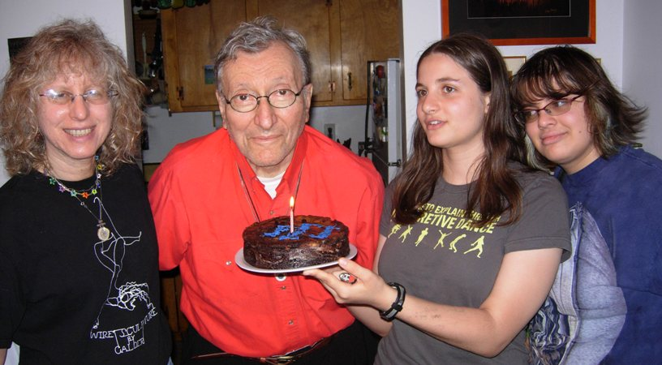
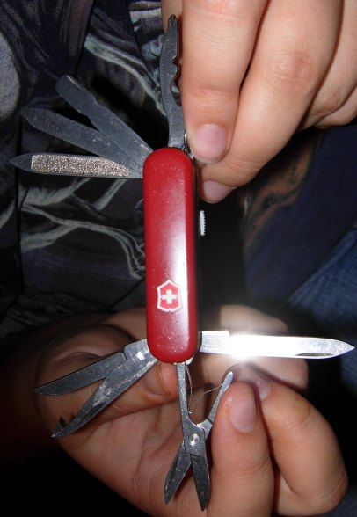
David Saphra
9 Divney Lane
Irvington, NY
10533-1403
Raphael Saphra
Fancy midget Swiss Army knife that no longer costs $12 like it did back in 2004 when George 1st ordered one.
Mon. 6/29/09
Camp Kinderland
1543 Colebrook River Road
Tolland, MA 01034
Dear Raphael,
As you can see from today’s visuals we spent a pleasant couple of hours this afternoon celebrating George Glasser’s 79th birthday. I managed to stay awake for most of it, which is more than I can say for your mother. At one point George pulled out a keychain with a highly desirable Swiss Army knife attached which proved an interesting area to delve into. It’s got a flashlight and a working pen attached to it. He’d ordered four of the knives at $12 each from a company in Tennessee that stocks over 200,000 different types of knives and actually keeps over a million items in stock. We called up the company on your mother’s cell phone because we wanted to get one of their catalogues, and then George got on to inquire about ordering some more knives, but the price had gone up to $38 in the meantime.

We left George a little earlier than we might have otherwise because we were trying to get down to the Upper West Side in order to hear an outdoor concert by the New York Consort of Viols. I tried with all my might to convince your sisters to come down with us but Naomi insisted she wouldn’t go unless Miriam came with us and Miriam could not be swayed. So it was just your mother and myself, in the end.
We actually got down to Manhattan very easily and found parking right away, so with some extra time to kill we decided to pay a visit to a Judaica store that was right around the corner from the community garden where the concert was to take place. I really went in mostly in order to buy a replacementh for the type of big fuzzy black yamulka I generally favor, but then I started trying out shofar’s and the next time thing you know I was walking out with a smallish $45 shofar that blows a very reliable concert C natural. I’ve got it sitting on the top of the piano at the moment hopefully well out of Ginger’s range.

The concert by the New York Consort of Viols got off to great start – the sound was very well amplified given the outdoor setting – but then started going downhill for a huge chunk of time what with an extremely boring presentation by a mime dressed and painted in green from top to bottom and an old clown who opened up a viol case and started randomly fooling around with a little pardessus viol for about 15 utterly useless minutes.

Worse was yet to come, though. The next item was a modern piece called Goldilocks and the Three Bears featuring a narrator that read an endlessly embellished adaptation of the usual fairtale. The best thing about the piece was that offered a decent argument as to why I should consider (or you for that matter!) writing music for this venue – viol quartet, since it wouldn’t take much effort to write a far better piece of music. It went on so long, and was so unappealing that people began to leave and someone way in the back started to call out “End it already” and this was hardly your image of a rowdy crowd by any stretch of the imagination. Eventually, the piece somehow did manage to wind itself down, but it must have been about a half hour long. No way it could have held any child’s interest for even a quarter of that, and most of the adults were probably ready to move on after the 1st thirty seconds of ugly music.

Things were fine after that, though for the rest of the conert, with the quartet playing the usual sort of f are. Afterwards we hung out for quite a while, since the woman that is the backbone of the group, Judith Davidoff, is the one who started me off on the viol about 35 years ago, while I was at Purchase College. Your mother and I then strolled around the Yupper West Side for a spell, stopping eventually off at an outdoor café for a bowl of soup and then headed for home to write this postcard.

Hope you’ve gotten off to a good start. I’ve ordered you the women’s history book you need to read as well as a couple of Lewis Thomas essay books I hope you’ll like. Tomorrow I’ve got to get up early in order to head on back down to the Bronx in so that Miriam and I can put the final touches on putting the music room in order. After that I might not ever be setting foot inside it again in my life. Looking forword to hearing from you soon..

Love, Da(d)vid

