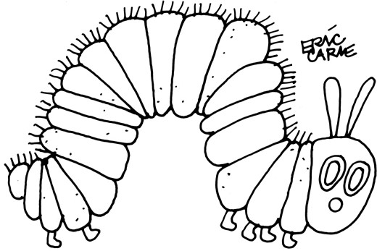
The Hungry Caterpillar
Sung to the tune of
“The Wheels on the Bus”

The Hungry Caterpillar likes healthy food,
Healthy food, healthy food
The Hungry Caterpillar likes healthy food
All through the day

The Hungry Caterpillar likes vegetables
Vegetables, vegetables
The Hungry Caterpillar likes vegetables
All through the day

The Hungry Caterpillar likes fine fresh fruit
Fine fresh fruit, fine fresh fruit
The Hungry Caterpillar likes fine fresh fruit
All through the day
The Hungry Caterpillar needs
water to drink
Water to drink, water to drink
The Hungry Caterpillar needs
water to drink
All through the day
The Hungry Caterpillar needs exercise
Exercise, exercise
The Hungry Caterpillar needs exercise
All through the day

The Hungry Caterpillar needs
love to grow
Love to grow, love to grow
The Hungry Caterpillar needs
love to grow
All through the day

