Name ____________________ Holiday Spirit Word Puzzle
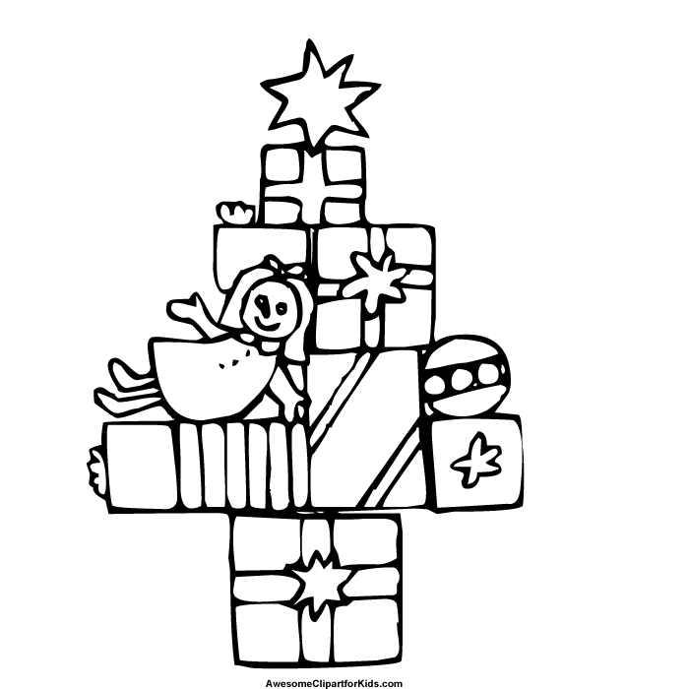
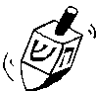
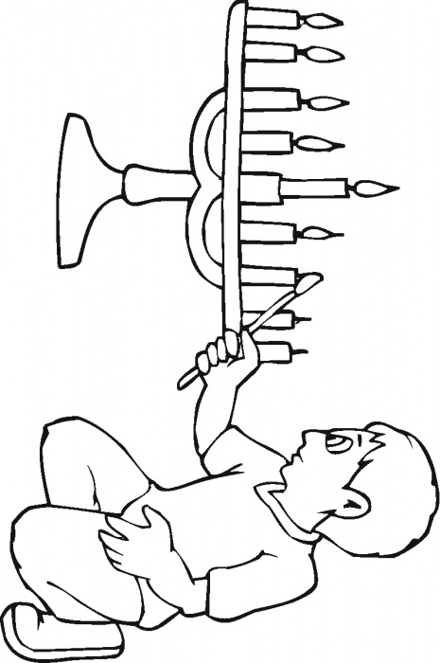
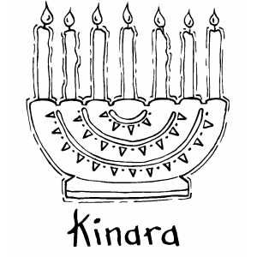
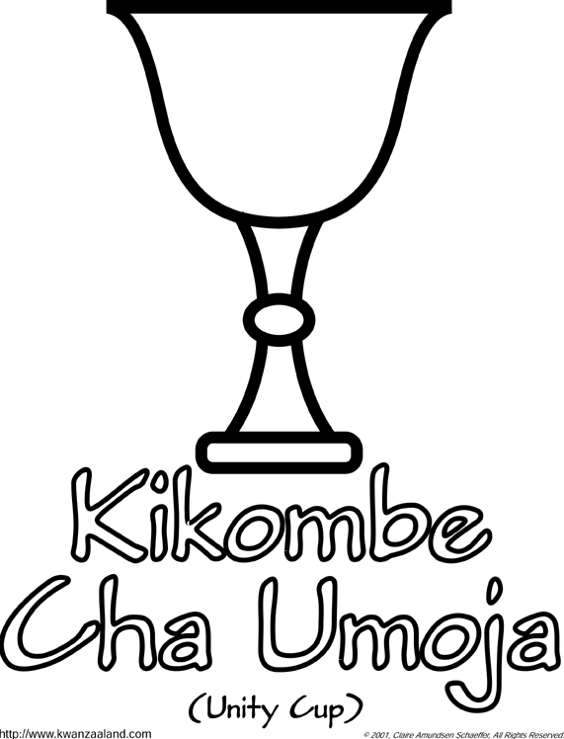
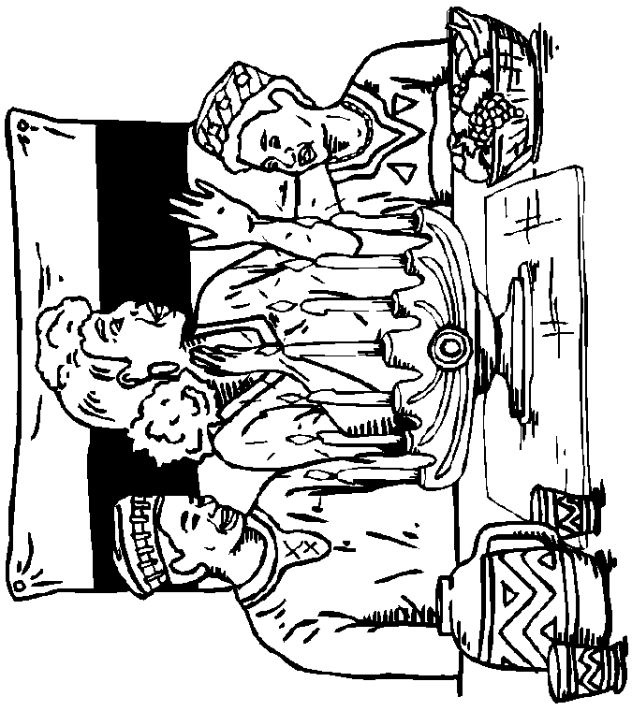
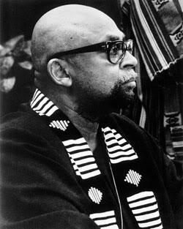
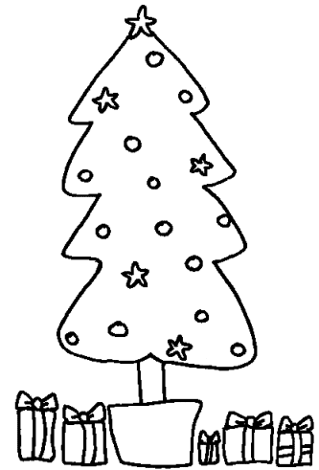
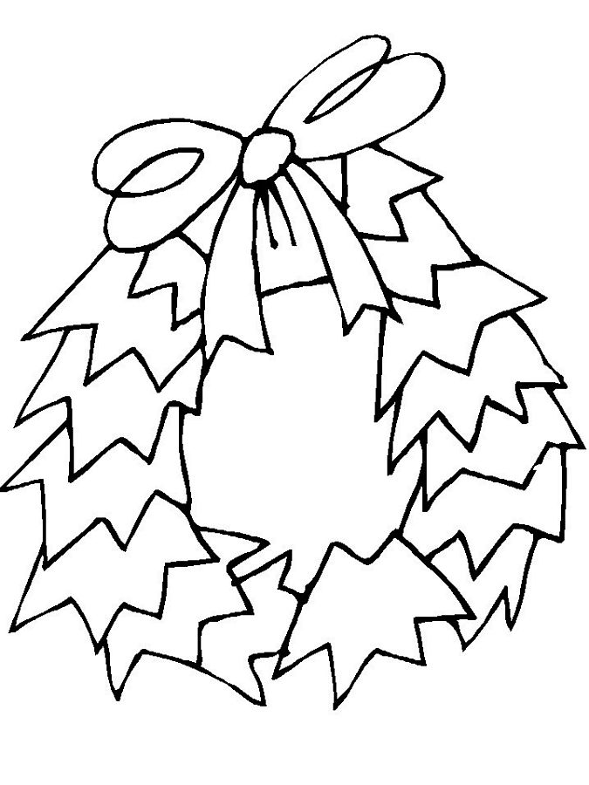
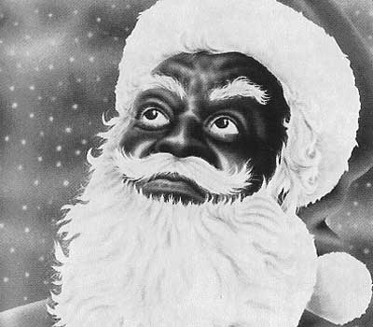
g t p C h r i s t m a s l o o n e W e a v e
l i e i t ' s h h o l i d a y s c o m e S e
e m r c o m e s h e l p a n d z a w a d i l
a e ' h a p p y t r e e s P w g w s k g n b
m C e l e b r a t e l l r y n e e s W n e a
i ' w t h e c o l o r e d i ' i e d i o o t
n G i f t s L e t ' s w l l l v e m n l g w
g W r e a t h s r e l l l i e l g ' t a n L
G f o l k s o o n ' a i m n l j a k e l i e
t i m e l r w t l c e a g a s u t e r y t t
g r e a t a s K e i f W c h ' s h k e s s '
n e v e r e d S w l d y d g t t ' a h a a s
b r i n g y d e p a l a a n i s r o f m e H
W e v e r y o n e i n o y i l g i s s t f a
t i m e g i v e a n r z s l a n n l e s y n
k i k u m b e g a d i i a l l i g d k i r u
k i n a r a e f n l o h t a a v T i t r o k
T a m e n o r a h s o o s f l a o e a h t a
c o m e s h a p p y u n g S a h p r l C s h
f u n f r o m t h e y e g w o n s d r i n k

- Christmas
- comes
- along
- just
- one
- time
- year
- We're
- so
- happy
- it's
- come
- Gifts
- and
- Christmas
- trees
- gath'ring
- families
- feasting
- and
- having
- fun
- Wreaths
- and
- colored
- lights
- gleaming
- gaily
- Let's
- let
- the
- holiday
- shine
- Let's
- all
- get
- the
- Christmas
- Spirit
- and
- we'll
- good
- time
- Hanukah
- comes
- along
- just
- one
- time
- a
- year
- We're
- so
- happy
- it's
- here
- now
- Presents
- and
- menorahs
- Help
- tell
- the
- great
- story
- how
- we
- need
- never
- give
- in
- to
- fear
- now
- Tops
- called
- Dreidls
- and
- latkes
- on
- the
- table
- Kwanzaa
- Weave
- a
- m'keka
- Let's
- drink
- from
- the
- Kikumbe
- Zawadi
- for
- everyone
- Celebrate
- for
- seven
- days
- Light
- the
- Kinara
- Winter
- Holidays
- come
- They
- bring
- us
- snow
- falling
- Folks
- calling
- lalala

